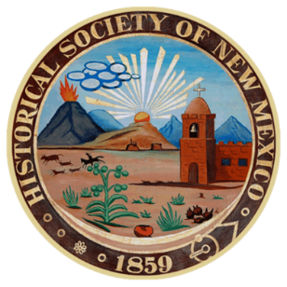
Historical Society of New Mexico
Speakers’ Bureau Completion Form

Note: Both the Speaker and Hosting Organization MUST be current, paid-up members of the Historical Society of New Mexico. If you have any questions, please call Janet Saiers at 505.299.5019. Please print out, complete and return this form to:

Speakers’ Bureau
Historical Society of New Mexico
P.O. Box 1912
Santa Fe, NM 87504-1912

Name of Organization__________________________________________________________
Organization Mailing Address____________________________________________________
Attesting Representative________________________________________________________

Presentation Date:________________________________Location:_____________________________

Name of Presenter ______________________________________________________________

Presentation Title: ______________________________________________________________

Approximate number of attendees:_________________________________________________

Evaluation of the presentation:
________________________________________________________________________________________________________________________________________________________________
________________________________________________________________________________

Other comments (Optional)__________________________________________________________

Signature of Host Representative: _____________________________________________________

